1.Draw and label a simple home network diagram showing a router, switch, and three devices (like a laptop, smartphone, and smart TV), indicating how each device connects to the network.
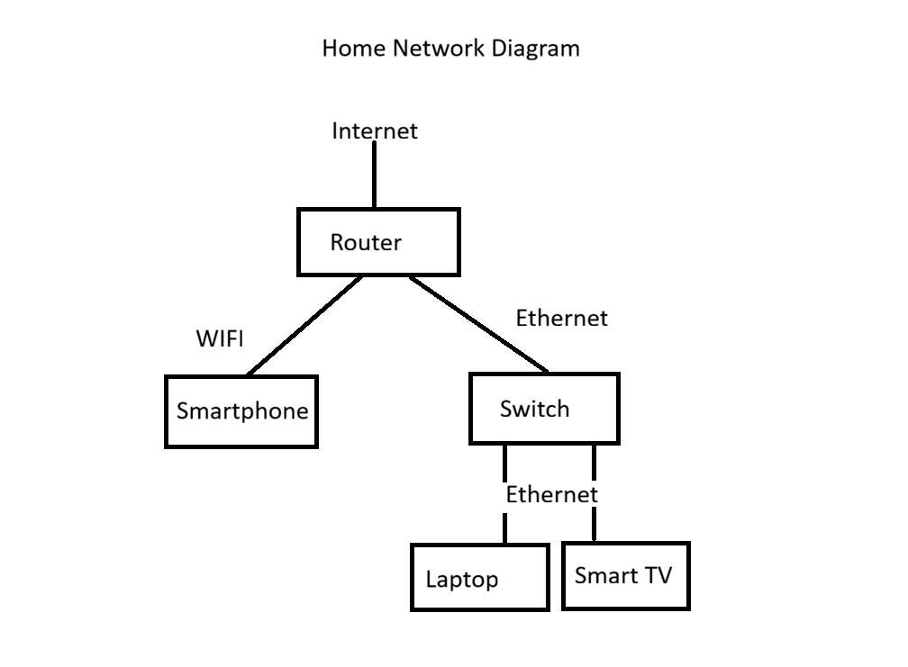
2.Create a comparison table listing at least four network devices (router, switch, hub, access point) and describe one real-world use case for each, referencing apps or services you use daily (e.g., WiFi for streaming on YouTube, LAN gaming, etc.).
Network Device | Main Function | Real-World Use Case
Router | Connects the local network to the Internet | Used at home to access the Internet for YouTube, Instagram, and web browsing.
Switch | Connects multiple devices in a LAN | Used in a college computer lab to connect many computers for file sharing and Internet access.
Hub | Sends data to all connected devices | Used in a small network for basic device communication (less common today).
Access Point (AP) | Provides wireless (Wi-Fi) connectivity | Used in homes or colleges so smartphones and laptops can connect to Wi-Fi for YouTube, WhatsApp, and online classes.

3.Write a short scenario where you explain how data travels from your phone to the internet when you order food on Zomato, mentioning the role of each network device involved (router, switch, access point).
->When I order food on Zomato using my smartphone, my phone first connects to the Access Point (Wi-Fi). The access point sends my request to the Switch, which forwards the data to the correct network device. Then, the Router sends the request to the Internet, where it reaches the Zomato server. The server processes my order and sends the response back through the Router, Switch, and Access Point to my phone. Finally, I can see the order confirmation and delivery details in the Zomato app.
4.Given this situation: you have a WiFi router, but your gaming PC only has an Ethernet port and is far from the router. Suggest two different network devices you could use to connect your PC to the internet and explain how each would work in this setup.<br><br><em><strong>Hint:</strong> Think about devices like switches, powerline adapters, or WiFi extenders.</em>
-> Option 1: Wi-Fi Extender

A Wi-Fi extender can be placed between the router and the gaming PC. It receives the Wi-Fi signal from the router and extends its range. The PC can then be connected to the extender using an Ethernet cable, giving it Internet access.

Option 2: Powerline Adapter

A powerline adapter uses the home's electrical wiring to carry network data. One adapter is connected to the router, and the second adapter is connected to the gaming PC with an Ethernet cable. This allows the PC to access the Internet without running a long Ethernet cable through the house.

Conclusion:
A Wi-Fi extender is useful for extending wireless coverage, while a powerline adapter provides a stable wired connection through the home's electrical wiring. Both are good solutions when the PC is far from the router.

